# How To: Manage your Files

All students have access to a personal secure drive called the I:Drive. You can access it on campus from File Explorer🡪This PC🡪 (I:) Personal and off campus via My Hope 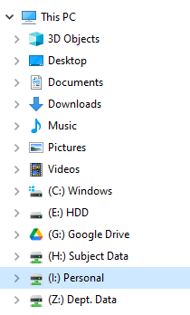

Level H students can access the psychology labs to conduct research, however there are a number of steps that must be completed before students can work in labs. These steps should be completed with support from your dissertation supervisor

1. **Ethical approval** must be obtained
2. **Standard Operating Procedures** for the room/equipment must be read and adhered to at all times
3. A **risk assessment** for your experiment for your individual study should be completed (this applies to all research, not just lab-based studies). [**Risk assessment templates are in this folder**](https://live.moodle.hope.ac.uk/mod/folder/view.php?id=86617)
4. Download and read the **COVID Risk Assessment** document
5. Download and adhere to the **Psychology Lab Protocol**
6. Lab access will only be granted upon production of a **Lab Access Form**, accompanied by an **approved ethics form** and **completed risk assessment**
7. Download and adhere to the **COVID Screening Information** document
8. Participants should complete a **COVID Screening Form** and the researcher should retain a copy of this, ensuring date and time of attendance is logged. Researchers should follow the instructions on this document in the event that a participant fails the COVID screening
9. Labs are booked via [**SONA**](https://live.moodle.hope.ac.uk/mod/folder/view.php?id=32123) . All students should have a SONA account which was converted to a Researcher account in preparation for Level H dissertation work